1. 
2. **Command 🡺 CTRL + N** : To navigate b/w classes or to search for a class.   
   
3. 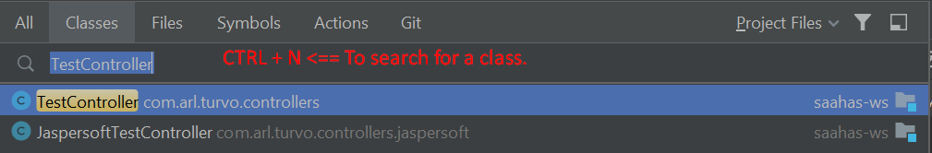
4. **Command** 🡺 CTRL + E: To see the list of recent files, you have been.  
   
5. 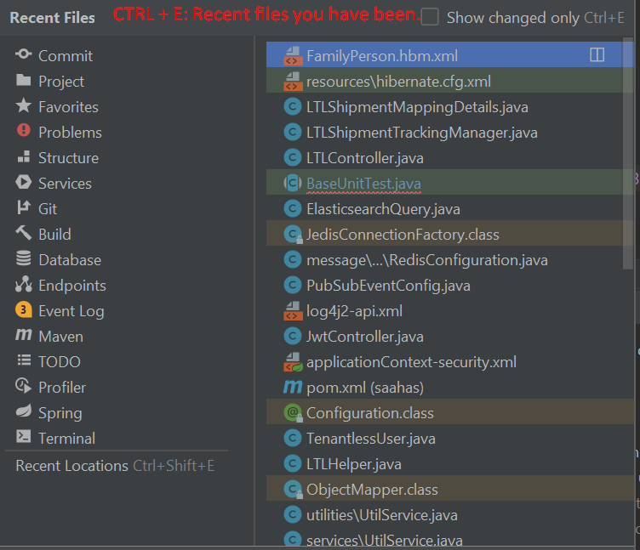
6. Command 🡺 CTRL + SHIFT + E🡸 Recently Edited file.  
   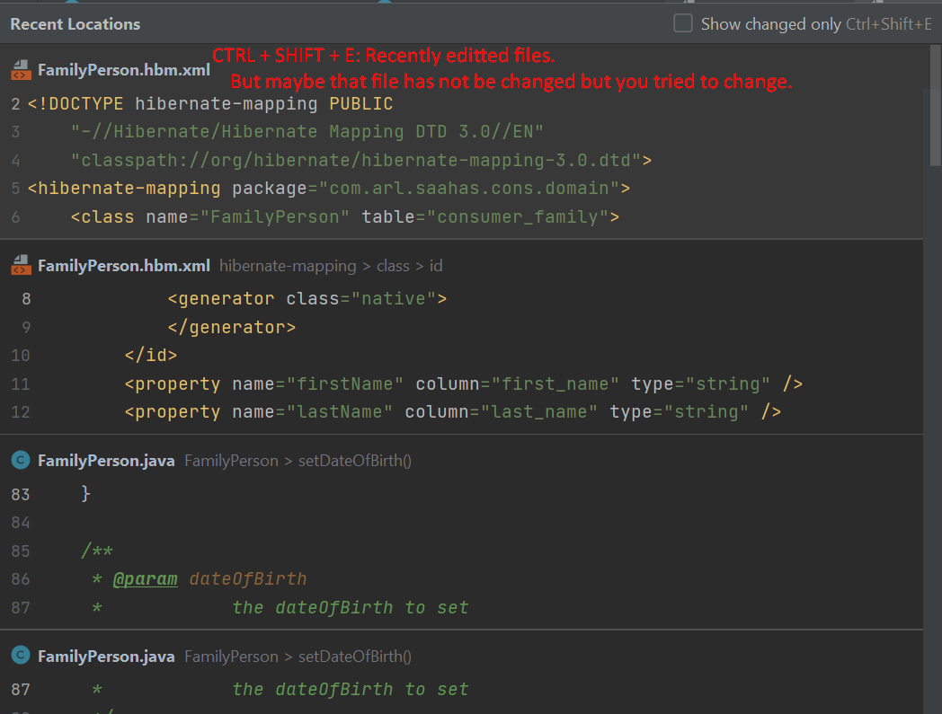
7. Command 🡺 To move back and forth where you have been.  
   